MSTDEV Student Computer Setup Guide
Setup Time: 60 minutes
Setup Overview: These setup instructions walk through the steps required to configure a Windows PC or a virtual machine (VM) that will be used by students when working on the lab exercises for MSTDEV: Modern SharePoint and Teams Development.

Task 1: Install and Configure Windows 10 or Windows 8.1
In this step you will install the Windows operating system.
- Install the x64 bit edition of Windows.
  - You can install either Windows 10 or Windows 8.1 to complete lab exercises.
  - Apply all Windows updates.
- Install the Chrome browser.
  - You should be able to access the Internet with Chrome and at least one other browser (e.g. Edge, Internet Explorer).
- Enable the execution of PowerShell scripts on your local PC.
  - Open a PowerShell command shell running as Admin and type in and execute the following PowerShell command.
Set-ExecutionPolicy Bypass -Scope CurrentUser
  - When prompted to confirm to the operation, type Y and press ENTER to confirm that you want to enable script execution.
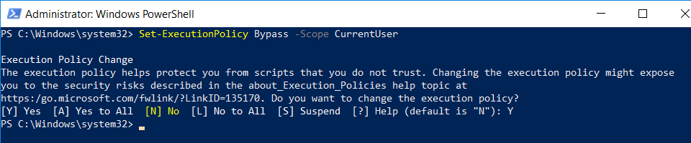

Task 2: Install the Azure AD PowerShell Modules
In this task you will install the PowerShell libraries required to work with Microsoft Azure resources. Note that if you are running Windows 8.1 instead of Windows 10, you must first install the Windows Management Framework 5.1. If you are running Windows 10, you do not need to perform this step.
- If you are running Windows 8.1, download and install the Windows Management Framework 5.1using the following link.
https://www.microsoft.com/en-us/download/details.aspx?id=54616
- Install the Azure PowerShell modules by executing the following PowerShell commands one at a time in the PowerShell console.
  - In the PowerShell console, execute the following command
Install-PackageProvider -Name NuGet -MinimumVersion 2.8.5.201 -Force

  - Next, execute the following command to trust the PowerShell gallery.
Set-PSRepository -Name PSGallery -InstallationPolicy Trusted

  - Next, execute the following command to install the most recent Azure PowerShell Az cmdlet library.
Install-Module -Name Az -AllowClobber -Scope CurrentUser

  - Finally, execute the following command to install the Azure Active Directory PowerShell cmdlets library.
Install-Module AzureAD -AllowClobber -Force

Task 3: Install the SharePoint Online Management Shell
In this task you will install the PowerShell library which is used to managed sites in SharePoint Online.
- Install the SharePoint Online Management Shell
  - In the browser, navigate to https://www.microsoft.com/en-us/download/details.aspx?id=35588
  - Click the Download button to download the installation program.
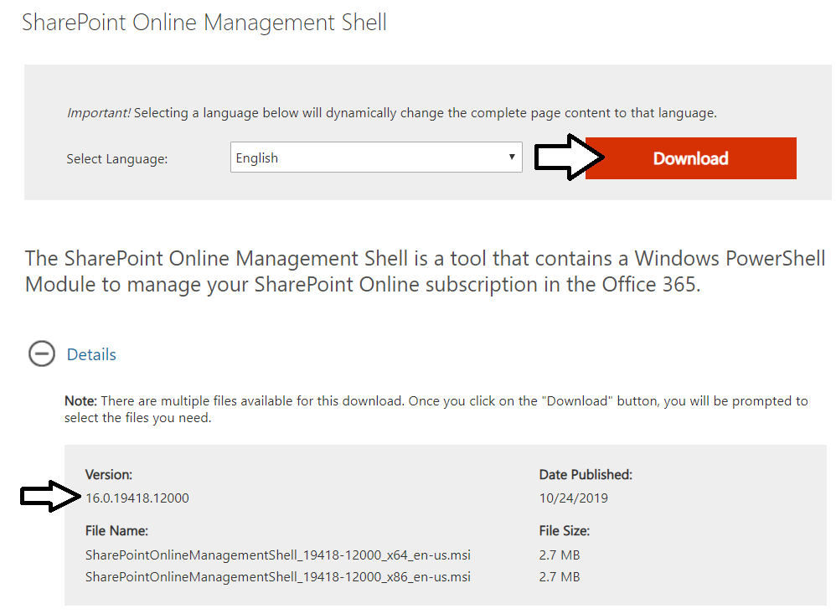
  - Make sure to select the download for the 64-bit version which has an x64 in its name.
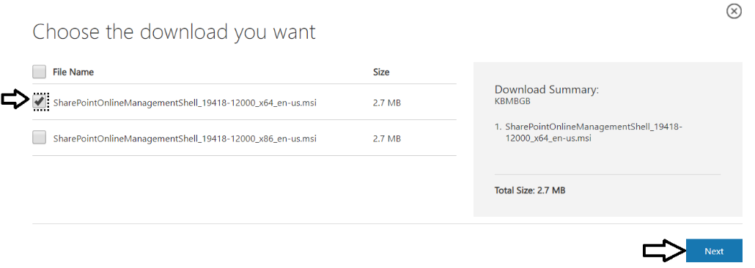
  - Begin the installation program and accept all the default settings.
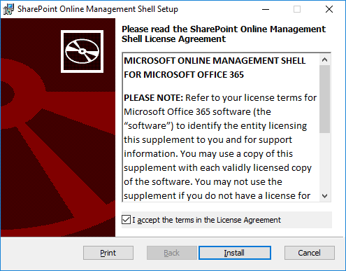
  - Follow the instructions to complete the installation.
- If you already have an Office 365 environment with SharePoint Online, you can test out the installation with the following steps. If you don’t already have an Office 365 environment with SharePoint Online, you can move ahead to the next step.
  - Press the Windows key to display the Windows Start menu and type in SharePoint. You should see the SharePoint Online Management Shell appear in the Start menu. Click on SharePoint Online Management Shell to launch a PowerShell console window.
  - Type cd\ into the console window and press ENTER to move the current directory to the root of the C:\ drive.
  - Type cls into the console window and press ENTER to clear the screen.
  - Type in the following PowerShell command and press ENTER. Make sure to replace cbd365 with the name of your Office 365 tenant and the name student with your account name,
Connect-SPOService -Url https://cbd365-admin.sharepoint.com -credential student@cbd365.onmicrosoft.com
  - When this command begins to execute, it will prompt you to login. When prompted, log in using our Office 354 account credentials.
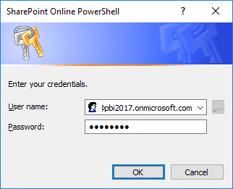
  - Once you have authenticated, the call to Connect-SPOService should return.
  - Type in Get-SPOSite and press ENTER
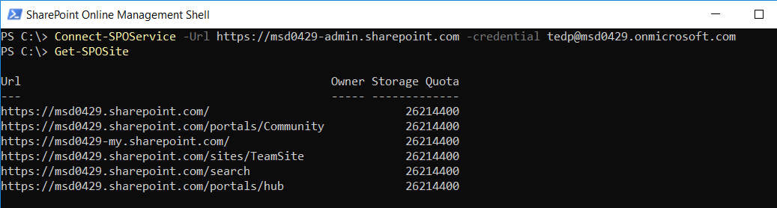
When the call to Get-SPOSite executes, it should display a list of the SharePoint Online sites in the current Office 365 tenancy. If you see the list of SharePoint Online sites, you know that the SharePoint Online Management Shell has been correctly installed.

Task 4: Install GIT
In this exercise, you will install the git utility.
- Launch a browser and navigate to the following link.
https://git-scm.com/download
- Download the installation files for git for Windows.
- Run the installation program. When prompted, agree to the terms and accept all the default settings.
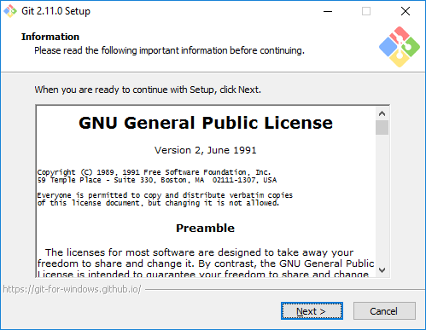
- Wait until the installation is complete.

Task 5: Install Visual Studio 2019
In this exercise, you will install Visual Studio 2019 Professional. Note if you don't have access to Visual Studio 2019 Professional, you can use the free community edition of Visual Studio 2019 to complete all the labs in this course.
- Obtain the installation software for Visual Studio 2019 Professional.
  - If you don't have a copy, you can download a trial of Visual Studio 2019 Pro edition using the following link.
https://visualstudio.microsoft.com/thank-you-downloading-visual-studio/?sku=Professional&rel=16
  - Once the installation program has downloaded and started running, click Continue to install Visual Studio 2019.
  - Wait while the installation program downloads packages and installs them
Once the core packages have been installed, the installation program will prompt you for which Workloads to install.
- Under Workloads tab in the Web and Cloud section, select the following workloads
  - ASP.NET and web development
- Under Workloads tab in the Desktop and Mobile section, select the following workloads
  - .NET desktop development
- Under Workloads tab in the Other Toolsets section, select the following workloads
  - Office/SharePoint Development
You should feel free to install other workloads if you’d like to. This setup guide lists the minimum needed for this training class.
- Move ahead in the installation program to the Summary section.
  - Locate and click the Install button in the bottom right corner to begin the installation.
Instalation will take about 20-30 minutes. When the installation is complete, you will see the a page telling you that Visual Studio 2017 has been installed.
- Launch Visual Studio 2019.
  - When you see the Welcome screen, it will prompt you to sign into Visual Studio Online. However, there is no need for you to log onto Visual Studio Online. Instead, click the Not now, maybe later link at the bottom of the Welcome screen
  - On the next screen, select a Development Setting for the color theme and then click Start Visual Studio.
  - Once Visual Studio has started, select the File > New Project command.
  - In the search box, type .NET Framework Console to locate the project template for a simple console application.
  - Create and test a simple console application to verify the Visual Studio has been installed correctly.
You are now done with your installation of Visual Studio 2019.

Task 6: Install Fiddler
In this exercise, you will install the Fiddler developer utility.
- Launch a browser and navigate to the following link.
https://www.telerik.com/download/fiddler
- Download the installation files for Fiddler.
- When the Fiddler installation program starts, it prompts you to accept the licensing agreement. Click I Agree.
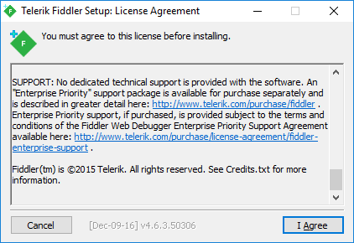
- Next, click the Install button to run the Fiddler installation program.
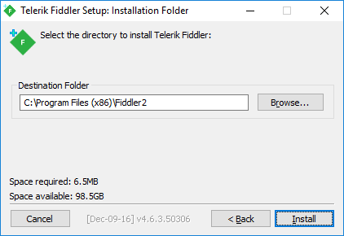
- When the Fiddler installation program completes, launch Fiddler from the Windows Start menu.
Steps 6, 7 and 8 only apply if you are using Windows 10. If you are using Windows 8.1, you can skip ahead.
- When Fiddler starts for the first time, it prompts you with the AppContainer Configuration dialog. Click the Cancel button to dismiss the dialog and prevent this dialog from reappearing later.
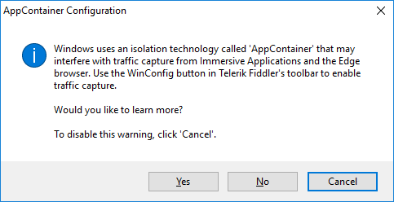
- Once Fiddler has started, click the WinConfig button in the toolbar in the top left-hand corner of the Fiddler window to display the AppContainer Loopback Exemption Utility dialog.
- In the AppContainer Loopback Exemption Utility dialog, select Microsoft Edge on the left and then click Save Changes.
- Configure Fiddler support inspecting HTTPS request that are using SSL.
  - Select the Tools > Options… command
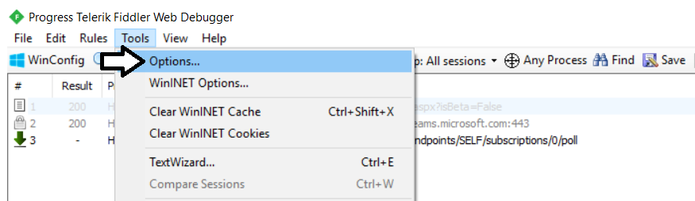
  - On the General tab of the Options dialog, uncheck the Notify me for updates on startup checkbox.
  - On the HTTPS tab of the Telerik Fiddler Options dialog, check the Decript HTTPS traffic checkbox.
  - Click Yes when prompted whether to Trust the Fiddler Root Certificate?
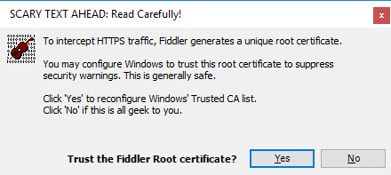
  - Click Yes, when you see the following dialog which asks Do you want to install this certificate.
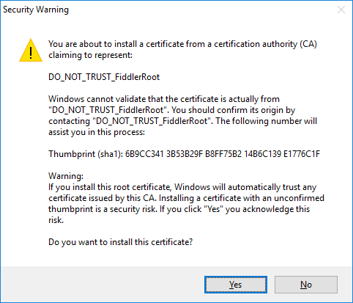
  - Click Yes one more time when you see the TrustCert Confirmation dialog.
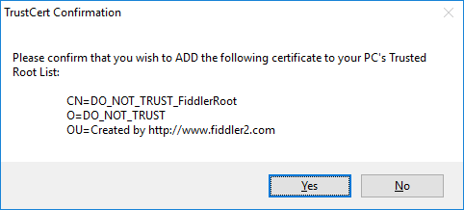
  - You should now see a dialog that confirms that Fiddler's root certificate has been added to the machine root list.
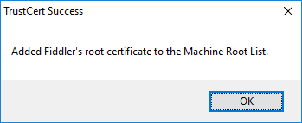
  - Select Ignore server certificate errors (unsafe) and then click OK to dismiss the Options dialog.
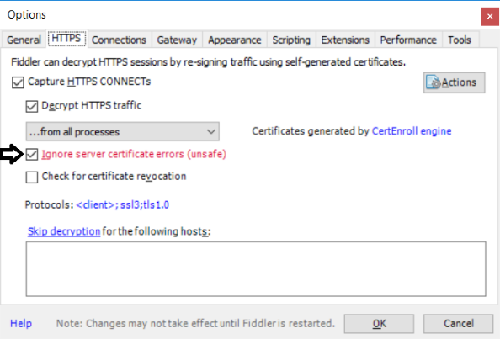
- Test out Fiddler.
  - Close and restart Fidler.
  - Launch the Chrome browser and navigate to a URL with SSL such as https://google.com.
  - Make sure you can use Fiddler to monitor HTTPS request.
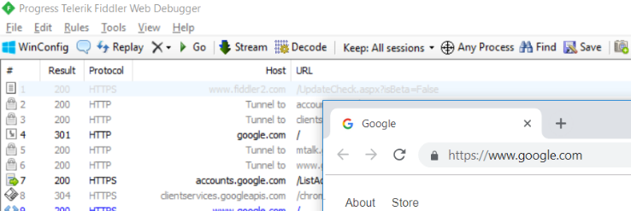
  - If you are using Windows 10, launch the Microsoft Edge browser and navigate to a URL with SSL such as https://bing.com.
  - Make sure you can use Fiddler to monitor HTTPS request.

Task 7: Install Node.js Version 10.x
In this task, you will install Node.js. Note there are more recent version of Node.js beyond version 10, but they are not compatible with the SharePoint Framework. Node.js version 10 is the most recent supported by the SharePoint Framework.
- Download the MSI file to install the latest release of Node.js version 10.
  - Navigate to the web page at the following URL.
https://nodejs.org/dist/latest-v10.x/
  - You should see a folder of files installation files similar to the folder shown in the following screenshot.
  - Download the MSI file with the name matching the pattern node-v10.x.y-x64.msi.
  - Once you have downloaded the MSI installation file, run it to begin the Node.js installation program.
  - When you see the Node.js Setup Wizard's Welcome screen, click Next.
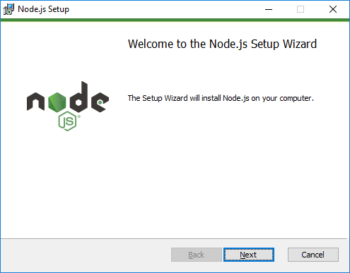
  - Agree to terms and click Next.
  - Accept (or modify) the installation folder and click Next.
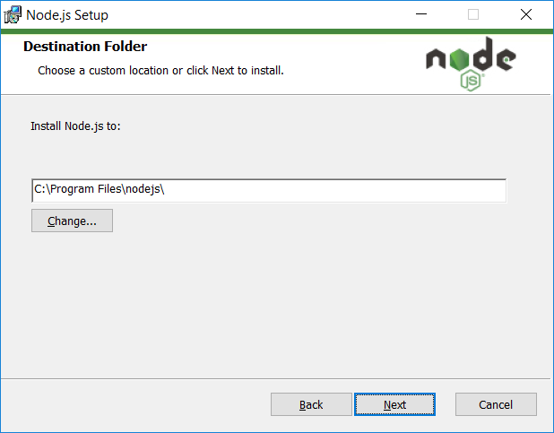
  - On the Custom Setup page, accept the default setting and click Next.
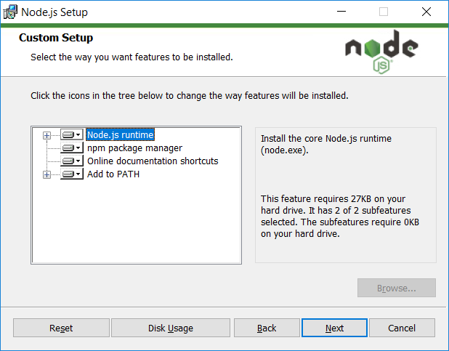
  - On the Ready to install Node.js page, click Install to begin the installation.
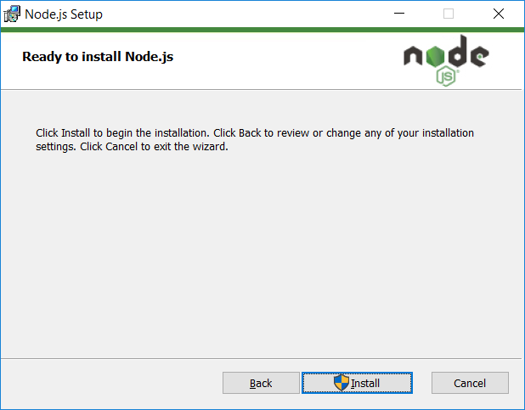
  - Wait until the installation completes and then click Finish.
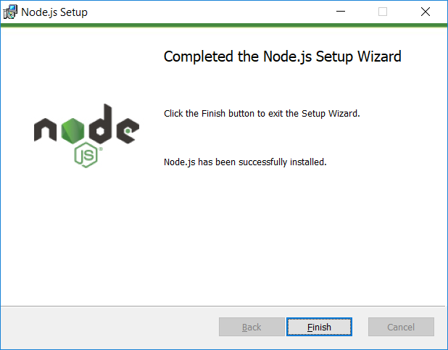
- Launch the Node.js command prompt.
  - In the Windows Start menu, locate and select the Node.js command prompt.
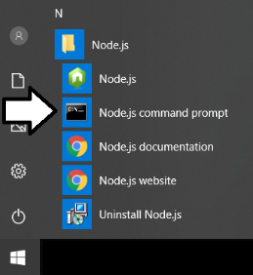
  - Verify the the Node.js command prompt launches without error and that the version number begins with an 10.

Task 8: Install Visual Studio Code
In this setup task, you will install Visual Studio Code.
- Launch a browser and navigate to the following link.
https://code.visualstudio.com/download
- Download the installation files for Visual Studio Code for Windows.
- Run the installation program for Visual Studio Code.
  - Click Next to move through the setup program.
  - When you get to the Select Additional Tasks dialog, select all options and click Next to continue.
  - When you get to the Ready to Install dialog, click Next to continue.
- Move through the dialogs of the installation program until you reach the Completing the Visual Studio Code Setup Wizard dialog. Click Finish.
- When the installation program completes, it should launch Visual Studio Code.
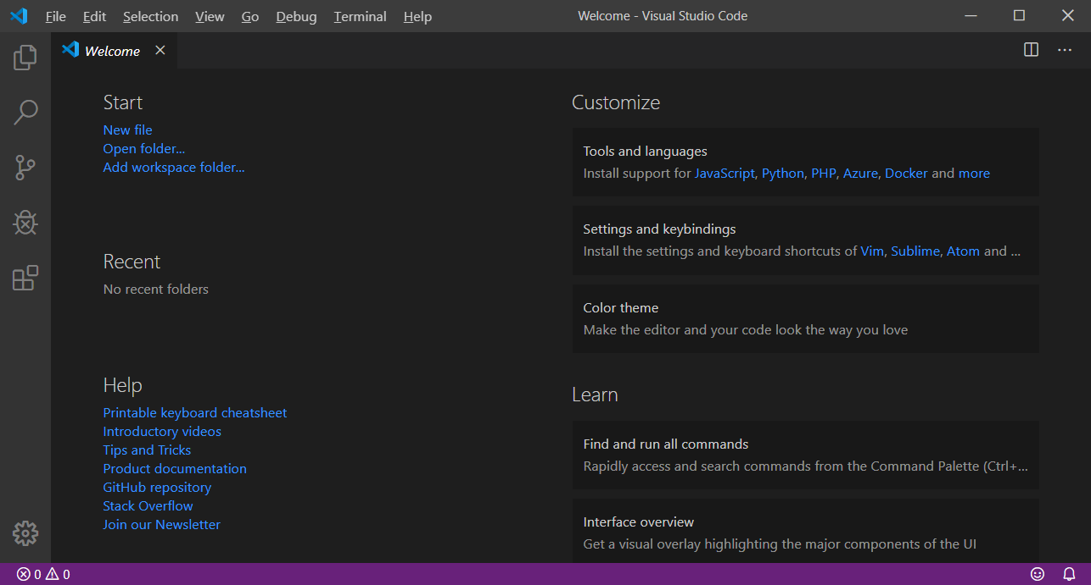

Task 9: Install the ngrok Utility
In this exercise, you will install the ngrok developer utility.
- Launch a browser and navigate to the following link.
https://ngrok.com/download
- Click the Download for Windows button to download a zip archive which contains ngrok.exe.
- Once you have downloaded the zip archive, extract ngrok.exe to a local folder such as c:\Tools.
You will use ngrok in several of the lab exercises in this training course. Follow the documentation on the ngrok website if you want to test the utility now.

